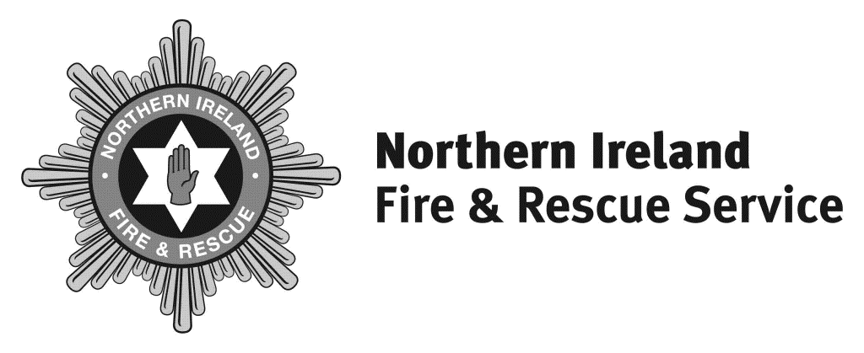

Headquarters
1 Seymour Street
Lisburn BT27 4SX

T 028 9266 4221

F 028 9267 7402
enquiries@nifrs.org
www.nifrs.org

Chief Fire & Rescue Officer

Michael Graham

Interim Chief Fire & Rescue Officer

Dale Ashford QFSM

Our Ref: GC/ FOI 88-20

21 January 2020

Dear

RE: FREEDOM OF INFORMATION REQUEST OF 01 JANUARY 2020

Please be advised of the following in relation to your request.

Please could you break down the below information per month (from the 1st to the 30th or 31st) for each month from April to December in 2020.

How many full-time firefighters employed within your service were forced to self-isolate after: testing positive for Covid-19, living with someone who had contracted the virus or had symptoms of it, having symptoms of coronavirus, being in close contact with someone in their support bubble that had symptoms or had tested positive for Covid-19, told by NHS Test and Trace or the NHS Covid-19 app to self-isolate, or arriving in the UK after visiting a country with a high coronavirus risk over this period?

See spreadsheet attached. https://www.nifrs.org/wp-content/uploads/2022/09/FOI-88-20-Statistics.xlsx

Overall, for how long (in hours) over the month period did fire stations under the authority of your fire service lose full time cover as a result of such isolation due to Covid-19?

Nil hours.

How many retained firefighters had to be used over this period in replacement?

None.

Review Process

Under the terms of the legislation, if you are unhappy with this response you have the right to seek a review within the Northern Ireland Fire & Rescue Service in the first instance. If you wish to do so, please write to Stuart Crawford the Governance, Information & Business Support Services Manager ,1 Seymour Street, Lisburn, BT27 4SX within two calendar months of the date of this letter.

If after such a review you are still unhappy with the response, you have the right to appeal to the Information Commissioner who will undertake an independent review.
The Information Commissioner contact details are – 3rd Floor 14 Cromac Place Belfast BT7 2JB.

Please visit www.nifrs.org for more information about NIFRS.

Yours sincerely

Information Officer

