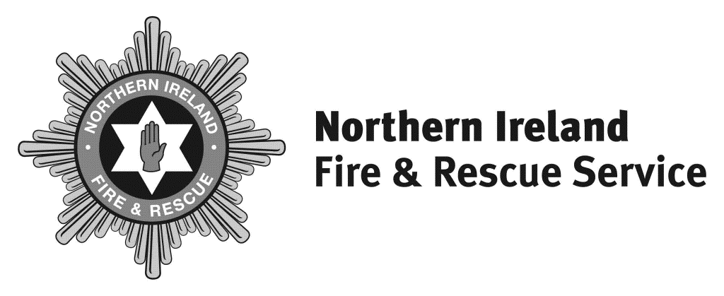

Headquarters
1 Seymour Street
Lisburn BT27 4SX

T 028 9266 4221

F 028 9267 7402
enquiries@nifrs.org
www.nifrs.org

Chief Fire & Rescue Officer

Michael Graham

Interim Chief Fire & Rescue Officer

Dale Ashford QFSM

Our Ref: LA/FOI 42-21-22

29 July 2021

RE: FREEDOM OF INFORMATION REQUEST DATED 1 JULY 2021

Please be advised of the following in relation to your request:

Can you please provide detail about training for successful candidates from the 2020 recruitment campaign (for whole time firefighters)?

The current initial training programme for successful candidates who are appointed as Wholetime Firefighters is 16 weeks but may be extended if required. The course ensures trainee firefighters have the required skills to be posted to stations and continuation training is carried out on stations.

Q1 How do you select the 100 trainees from the 369 successful candidates?

As per the candidate information pack (please see attached), offers to candidates are made in rank order from the reserve list.

Q2 As previously stated, the first intake of trainees began training in February 2021. Can you provide dates of subsequent training courses for trainees during 2021/2022?

We cannot provide any further dates of intakes as these have not been agreed at this time and are subject to organisational need and budget.

Q3 How much notice do successful candidates receive that they have been selected to become trainees and attend this training?

Candidates will be given as much notice as possible of a potential start and this can vary depending on organisational need.

A copy of the Wholetime Firefighter candidate information pack has been attached for information.

Review Process

Under the terms of the legislation, if you are unhappy with this response you have the right to seek a review within the Northern Ireland Fire & Rescue Service in the first instance. If you wish to do so, please write to Stuart Crawford the Governance, Information & Business Support Services Manager ,1 Seymour Street, Lisburn, BT27 4SX within two calendar months of the date of this letter.

If after such a review you are still unhappy with the response, you have the right to appeal to the Information Commissioner who will undertake an independent review.
The Information Commissioner contact details are – 3rd Floor 14 Cromac Place Belfast BT7 2JB.

Please visit www.nifrs.org for more information about NIFRS.

Yours sincerely

Information Unit

