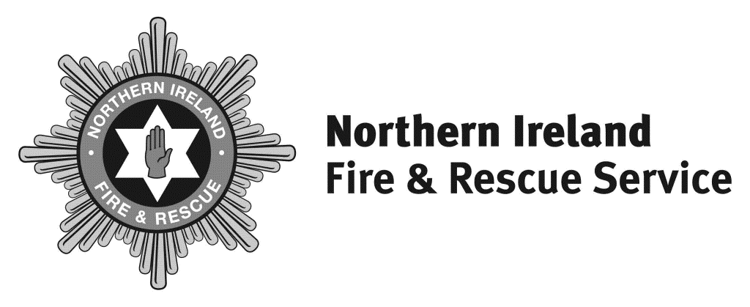

Headquarters
1 Seymour Street
Lisburn BT27 4SX

T 028 9266 4221

F 028 9267 7402
enquiries@nifrs.org
www.nifrs.org

Chief Fire & Rescue Officer

Michael Graham

Interim Chief Fire & Rescue Officer

Dale Ashford QFSM

Our Ref: RG/ FOI 117-20

30 March 2021

Dear

RE: FREEDOM OF INFORMATION REQUEST OF 24 MARCH 2021

Please be advised of the following in relation to your request
- How many firefighters are currently employed by your fire service?
As at 28 February 2021 there were 1698 Wholetime and On-Call operational employees
- How many of your firefighters are on call?
As at 28th February 2021 NIFRS employed 898 On-Call operational employees.
- How many hours are your on call firefighters (if any) contracted to per week as a minimum?
NIFRS has a series of On-Call contracts which are outlined below;
Day Time Only - a minimum of 40 hours each week between 8 am – 6 pm, Monday to Friday.
Banded – a minimum of 100 hours each week which needs to include a minimum 48*hours within the following Bands:

Band 1: Friday 1800 to Sunday 1800
(must provide at least 24 hours* availability within this Band each week)
Band 2: Monday - Friday 0800 – 1800
(it is not essential to provide availability within this Band each week if the minimum 48 hour requirement has been provided in Band 1)
120 Hour Contract – provide a minimum of 120 hours each week across a range of times. This contract is currently under review.
- Do all your on call firefighters have an annual appraisal?
Not currently but a pilot system is currently being developed.
- Are their appraisals conducted on a one to one basis?
Not applicable currently but will be going forward.
- Who conducts the appraisal and do you have an example of the form used?
Appraisals are not conducted at this time. A form is currently in development in line with the pilot system.
- Are there any other forms of acknowledging good performance/achievements by on call firefighters?
NIFRS has an annual employee awards ceremony and specific achievements will be acknowledged during this ceremony.
- What, if any, equipment (other than clothing and pager/alerter) are your on call firefighters provided with?
All on-call firefighters are provided with a uniform, PPE and pager.
- Are email bulletins/updates sent directly to all on call firefighters? If so, how regularly?
Yes, these are issued centrally which are delivered on drill nights each week. Whatsapp groups are also used to communicate messaging directly when required.
- What is your HMI inspection rating?
NIFRS does not have a HMI inspection rating as it does not fall under the inspection programme undertaken by Her Majesty’s Inspectorate of Constabulary and Fire & Rescue Services (HMICFRS) which is currently limited to the 45 English Fire & Rescue Services.

Review Process

Under the terms of the legislation, if you are unhappy with this response you have the right to seek a review within the Northern Ireland Fire & Rescue Service in the first instance. If you wish to do so, please write to Stuart Crawford the Governance, Information & Business Support Services Manager, 1 Seymour Street, Lisburn, BT27 4SX within two calendar months of the date of this letter.

If after such a review you are still unhappy with the response, you have the right to appeal to the Information Commissioner who will undertake an independent review.
The Information Commissioner contact details are – 3rd Floor 14 Cromac Place Belfast BT7 2JB.

Please visit www.nifrs.org for more information about NIFRS.

Yours sincerely

Information Officer

