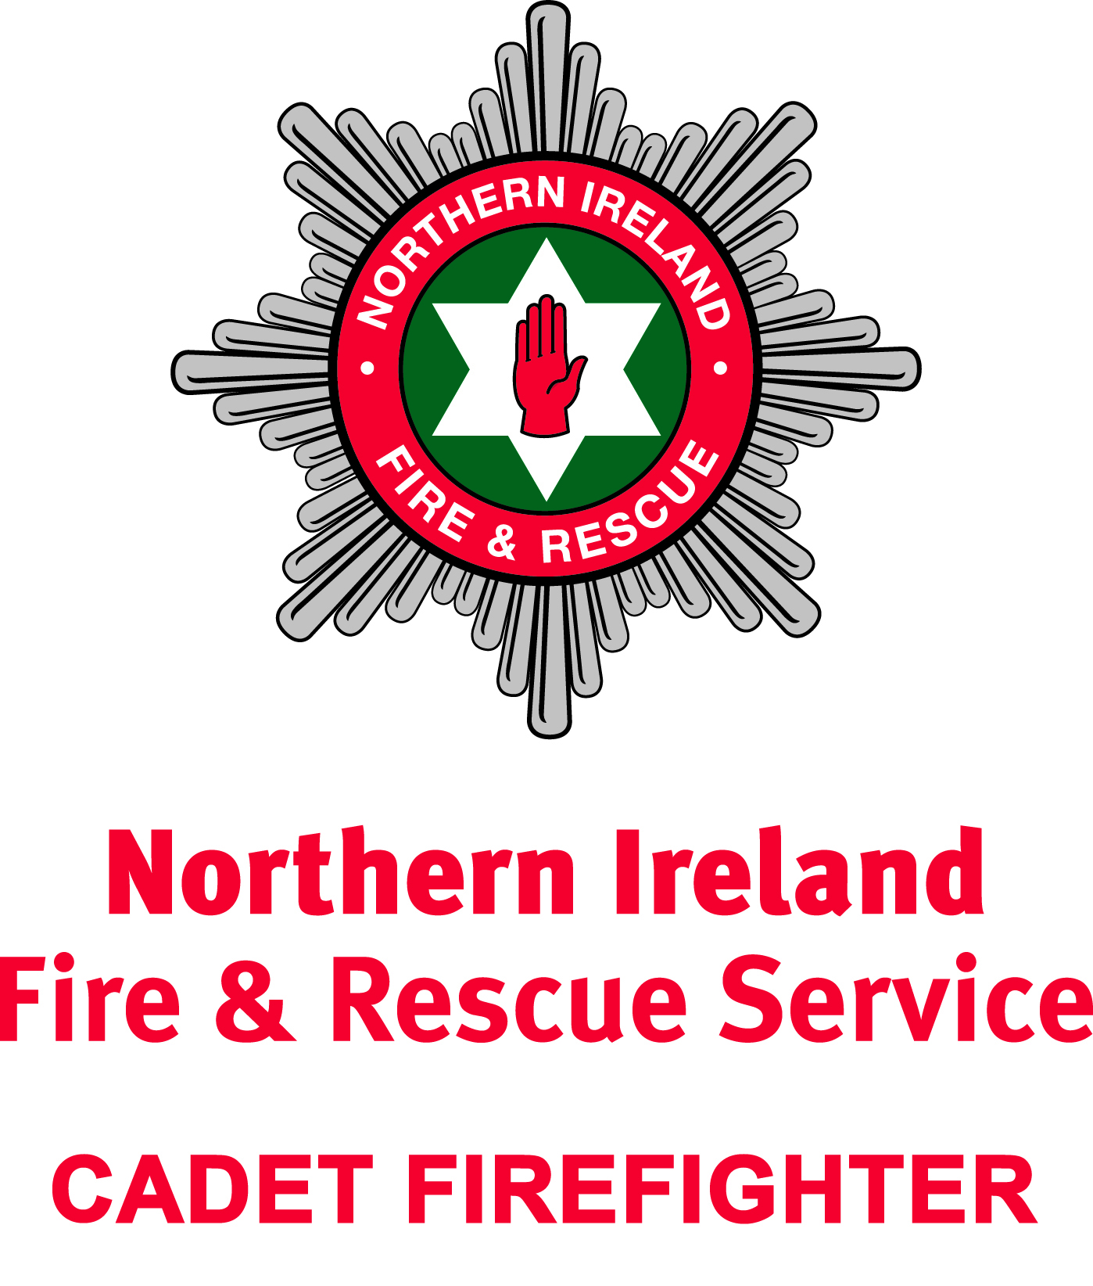
SC157
NORTHERN IRELAND FIRE & RESCUE SERVICE

CADET FIREFIGHTER APPLICATION

PLEASE COMPLETE ALL SECTIONS OF THIS APPLICATION FORM USING BLOCK CAPITALS

ESSENTIAL CRITERIA FOR APPLICANTS:

- You are starting School Year 11 in the September of the recruitment year; and
- Be under 15 years old by 1 July of the recruitment year.

All applicants should satisfy at least one of the following two criteria:

- Live within the geographical location of the Cadet Branch, ie, Bangor (Ards & North Down), Belfast, Lisburn or Newry.
- Go to school within the geographical location of the Cadet Branch, ie, Bangor (Ards & North Down), Belfast, Lisburn or Newry.

Priority will be given to applicants who meet the above geographical criteria in the first instance. Should spaces still be available after this criteria is applied, applications will then be considered from a wider geographical area, encompassing the Fire Service’s District boundaries.
Please choose which Cadet Branch you are applying for by checking one of the boxes below:
Bangor  (Monday Evening,  1900-2100)  Belfast  (Wednesday Evening, 1900-2100) |  |  | Lisburn  (Tuesday Evening,  1900-2100)  Newry  (Wednesday Evening, 1900-2100)

SECTION 1 – APPLICANT DETAILS
Forename: |  | Surname:
Gender:  (Optional) |  | Date of Birth:
 |  | (Proof of DOB will be required)
School Attended (including address):

SECTION 2 – PARENT/GUARDIAN DETAILS
Forename: |  | Surname:
Relationship to  applicant: |  | Tel Number:
Home address:
 |  |  |  | Postcode:
Email:

I confirm that my child is aware of and can commit to the requirements below.

Please tick to confirm your availability to:
- Attend weekly for approximately 40 weeks per school year
- Sign up for the duration of the Scheme
(2 or 3 years dependant on Branch)
I give consent for my child to apply for NIFRS’ Cadet Scheme*.

Signature: Date:
Parent’s signature

* Signing for parental consent - those individuals with parental responsibility include the natural mother, natural father (if married to the child’s mother at time of birth), an unmarried father if he is on the birth certificate or a natural father who marries the mother after the child’s birth and lives in Northern Ireland.

SECTION 3 – CHILD’S SIGNATURE
Signature: Date:
Child’s signature

Email this Application Form to cadets@nifrs.org to arrive by the advertised closing date with the subject line within the email indicating the Cadet Branch you are applying to. NIFRS will be in contact with you to inform you of the outcome of your application.

If you require any support completing or submitting the Cadet Firefighter Application Form, please contact the Prevention Department at NIFRS HQ on 028 9266 4221.

