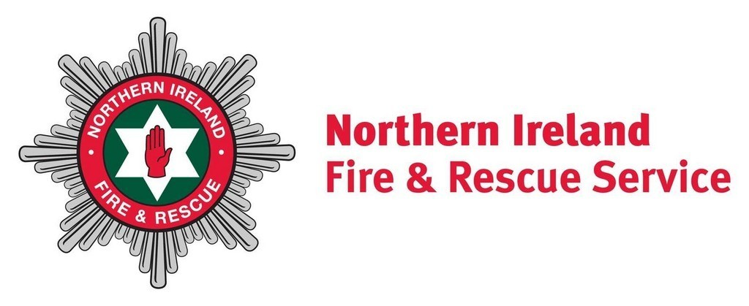 | Fire Safety Risk Assessment  Template for  Simple Premises

This template has been provided to assist small businesses in completing a fire safety risk assessment. It is suitable for use in simple premises, with a simple internal layout and small numbers of people present. For more complicated premises, a more comprehensive risk assessment will be required. It is used entirely at your own risk to assist to identify and record what you consider are your significant findings and the measures which have been or will be taken. It is your responsibility to ensure that the fire risk assessment is suitable and sufficient. This template is in no way exhaustive and Northern Ireland Fire and Rescue Service accepts no liability for any circumstances which may arise as a result of its use.

Before you begin, you are advised to consult the relevant Fire Safety Risk Assessment Guide, which explains how to carry out a Fire Safety Risk Assessment and the measures which you will need to consider. Guides are available free of charge from the Northern Ireland Fire & Rescue website at www.nifrs.org.

FIRE SAFETY RISK ASSESSMENT GUIDES
- Animal Premises
- Educational Premises
- Factories and Warehouses
- Healthcare Premises
- Large Places of Assembly
- Offices and Shops
- Open Air Events and Venues
- Residential Care Premises
- Sleeping Accommodation
- Small and Medium Places of Assembly
- Theatres, Cinemas and Similar Premises
- Transport Premises and Facilities

FIRE SAFETY LAW ADVICE
- Fire Safety Law - Are you Aware of Your Responsibilities?
- Fire Safety Law - The Evacuation of Disabled People from Buildings

SPECIFIC PREMISES GUIDES
- Small B&B Premises Guide
- Small Self-Catering Premises
- HMO Fire Safety Guide
- Caravan Site Operators Guide

FIRE SAFETY RISK ASSESSMENT

Company Name:

Premises Name:

Address:

Use of the Premises:

Previous Fire History:

Appropriate Person:

Persons Consulted:

Carried out by:

Position:

Date of Assessment:

OCCUPANCY

 | Weekdays | Weekends
Times Occupied:
Number of Staff:
Number of all Persons Present:
Number of Persons Sleeping on Premises:

SIZE

Total Size of Premises (m²):

Number of Storeys:

Number of Basements:

Step 1 Identify fire hazards (sources of ignition)

Recording your findings in the table below. If you are in any doubt if existing control measures are suitable, you should answer NO. This will be a significant finding which you need to record and develop an action plan for in Step 4.

Type | Existing Control Measures | Are existing control measures suitable?  YES / NO / NA
Naked Flames
Portable Heaters and Heating Equipment
Electrical Equipment
Cooking Equipment
Work Process Risks
Arson, Antisocial Behaviour
Smoking Materials
Contractors Hot Working
Other
Add the significant findings to your action plan in Step 4

Step 1 Identify fire hazards (sources of fuel and oxygen)

Recording your findings in the table below. If you are in any doubt if existing control measures are suitable, you should answer NO. This will be a significant finding which you need to record and develop an action plan for in Step 4.

Type | Existing Control Measures | Are existing control measures suitable?  YES / NO / NA
Wood, wood chips, paper, cardboard.
Plastics, rubber, foam, laundry, bedding.
Displays, stands, retail stock.
Furniture, fixings, fittings, floor coverings, wall surfaces, ceiling tiles, curtains.
Flammable chemicals, gases, liquids, paints, thinners, glues, etc.
Display materials, decorations or seasonal decorations.
Waste storage, containers, skips, refuse bins, etc.
Fireworks, pyrotechnics, aerosols
Oxygen supplies, air conditioning units, oxygen bottles, piped supply, oxidising substances, etc.
Other.
Add the significant findings to your action plan in Step 4

Step 2 Identify people at risk

Recording your findings in the table below. If you are in any doubt if existing control measures are suitable, you should answer NO. This will be a significant finding which you need to record and develop an action plan for in Step 4.

Type | Existing Control Measures | Are existing control measures suitable?  YES / NO / NA
People asleep, who will be slow to respond and disorientated.
People who work alone and/or in isolated areas.
People unfamiliar with the premises, e.g. guests, visitors, customers, seasonal staff, new staff and contractors.
Unaccompanied children and young persons, people with disabilities including mobility impairment or hearing or vision impairment, etc.
Staff or residents who are unable to escape unaided and who may require a Personal Emergency Evacuation Plan (PEEP).
People who are not able to leave the premises quickly, e.g parents with children.
Other people in the immediate vicinity of your premises.
Add the significant findings to your action plan in Step 4

Step 3 Evaluate, remove, reduce and protect from risk

Recording your findings in the table below. If you are in any doubt if existing control measures are suitable, you should answer NO. This will be a significant finding which you need to record and develop an action plan for in Step 4.

Fire-detection and warning systems | Are existing control measures suitable?  YES / NO / NA
Can the existing means of detection ensure a fire is discovered quickly enough for the alarm to be raised in time for all the occupants to escape to a place of total safety?
Are the detectors of the right type and in the appropriate locations?
Can the means of warning be clearly heard and understood by everyone throughout the whole building when initiated from a single point?
Are there provisions for people or locations where the alarm cannot be heard?
If the fire-detection and warning system is electrically powered, does it have a back-up power supply?
Firefighting equipment and facilities | Are existing control measures suitable?  YES / NO / NA
Are the extinguishers suitable for the purpose?
Are there enough extinguishers (or fire blankets, etc.) sited throughout the premises at appropriate locations?
Are the right types of extinguishers located close to the fire hazards and can users get to them without exposing themselves to risk?
Are the extinguishers visible or their positions clearly indicated?
Have you taken steps to prevent the misuse of extinguishers?
Do you regularly check any other equipment provided to help maintain the escape routes?
Do you carry out daily checks to ensure that there is clear access for fire engines?
Are those who test and maintain the equipment competent to do so?
Do you have the necessary procedures in place to maintain any facilities that have been provided for the safety of people in the building (or for the use of firefighters, such as access for fire engines and firefighting lifts)?
Add the significant findings to your action plan in Step 4

Escape routes | Are existing control measures suitable?  YES / NO / NA
Is your building constructed, particularly in the case of multi-storey buildings, so that, if there is a fire, heat and smoke will not spread uncontrolled through the building to the extent that people are unable to use the escape routes?
Are any holes or gaps in walls, ceilings and floors properly sealed, e.g. where services such as ventilation ducts and electrical cables pass through them?
Can all the occupants escape to a place of total safety in a reasonable time?
Are the existing escape routes adequate for the numbers and type of people that may need to use them, e.g. staff, members of the public, young children, and disabled people?
Are the exits in the right place and do the escape routes lead as directly as possible to a place of total safety?
If there is a fire, will at least one route from any part of the premises remain available and unaffected for escape?
Are the escape routes and final exits kept clear at all times?
Do the doors on escape routes open in the direction of escape?
Can all final exit doors be opened easily and immediately if there is an emergency?
Will everybody be able to safely use the escape routes from your premises?
Are the people who work in the building aware of the importance of maintaining the safety of the escape routes, e.g. by ensuring that fire doors are not wedged open and that combustible materials are not stored within escape routes?
Have you considered all the issues particular to your premises layout?
Emergency escape lighting | Are existing control measures suitable?  YES / NO / NA
Are your premises used during periods of darkness?
Will there always be sufficient lighting to safely use escape routes?
Do you have back-up power supplies for your emergency lighting?
Add the significant findings to your action plan in Step 4

Signs and notices | Are existing control measures suitable?  YES / NO / NA
Where necessary are escape routes and exits, the locations of firefighting equipment and emergency fire telephones indicated by appropriate signs?
Have you provided notices such as those giving information on how to operate security devices on exit doors, those indicating doors enclosing fire hazards that must be kept shut and fire action notices for staff and other people?
Are you maintaining all the necessary signs and notices so that they continue to be correct, legible and understood?
Are you maintaining signs that you have provided for the information of the Fire and Rescue Service, such as those indicating the location of water suppression stop valves and the storage of hazardous substances?
Installation, testing and maintenance | Are existing control measures suitable?  YES / NO / NA
Do you regularly check all fire doors and escape routes and associated lighting and signs?
Do you regularly check all your firefighting equipment?
Do you regularly check your fire-detection and alarm equipment?
Are those who test and maintain the equipment competent to do so?
Do you keep a log book to record tests and maintenance?
Add the significant findings to your action plan in Step 4

Step 3 Confirmation Checklist | Are existing control measures suitable?  YES / NO / NA
Have you evaluated the risk to people in your building if a fire starts?
Have you removed or reduced the hazards that might cause a fire?
Have you removed or reduced sources of ignition?
Have you removed or reduced sources of fuel?
Have you removed or reduced sources of air or oxygen?
Have you considered the need for fire detection and for warning?
Have you considered the need for firefighting equipment?
Have you determined whether your escape routes are adequate?
Have you determined whether your lighting and emergency lighting are adequate?
Have you checked that you have adequate signs and notices?
Have you confirmed there is regularly testing and maintenance of safety equipment?
Have you considered whether you need any other equipment or facilities?
Add the significant findings to your action plan in Step 4

Step 4 Record, plan, inform, instruct and train

Recording your findings in the table below. If you are in any doubt if existing arrangements are suitable, you should answer NO. This will be a significant finding which you need to record and develop an action plan for in Step 4.

Emergency Plan Checklist | Are existing arrangements suitable?  YES / NO / NA
Do you have an emergency plan and, where necessary, have you recorded the details?
Does your plan take account of other emergency plans applicable in the building?
Is the plan readily available for staff to read?
Is the emergency plan available to the enforcing authority?
Inform, instruct, co-operate and co-ordinate checklist | Are existing arrangements suitable?  YES / NO / NA
Have you told your staff about the emergency plan?
Have you informed guests and visitors about what to do in an emergency?
Have you identified people you have nominated to do a particular task?
Have you given staff information about any dangerous substances?
Do you have arrangements for informing temporary or agency staff?
Do you have arrangements for informing other employers whose staff are guest workers in your premises, such as maintenance contractors and cleaners?
Have you co-ordinated your fire safety arrangements with other appropriate people in the building?
Have you recorded details of any information or instructions you have given and the details of any arrangements for co-operation and co-ordination with others?
Add the significant findings to your action plan in Step 4

Fire Safety Training Checklist | Are existing arrangements suitable?  YES / NO / NA
Have your staff received fire safety training?
Have you carried out a fire drill recently?
Are employees aware of specific tasks if there is a fire?
Are you maintaining a record of training sessions?
Do you carry out joint training and fire drills in multi-occupied buildings?
If you use or store hazardous or explosive substances have your staff received appropriate training?
Add the significant findings to your action plan in Step 4

Step 4 Action Plan

Each significant finding will require action to be taken and be prioritised as follows:

Priority 1: | Needs attention immediately.
Priority 2: | Needs attention within 1 month.
Priority 3: | Needs attention within the next 6 months.
Priority 4: | Needs attention within the next 12 months.

It will assist you to list the actions in priority order.

What needs to be done? | Priority | Action required  by whom | Date  Due | Date  Complete

Add additional pages or rows as appropriate.

Step 5 Review

You should constantly monitor what you are doing to implement the action plan and assess how effectively the fire risk is being controlled.

Northern Ireland Fire & Rescue Service would recommend that you review your fire safety risk assessment regularly and at least every 12 months. You are legally required to review your risk assessment, if you have any reason to suspect that your fire risk assessment is no longer valid or there has been a significant change in your premises that has affected your fire precautions. Examples include:

- if you make changes to the layout of your premises;
- any changes to work processes;
- significantly increase the amount of combustible materials present;
- new or increased sources of ignition introduced;
- change to your opening hours such as night time opening;
- any failures in your fire safety precautions; or
- if a fire or 'near miss' occurs.

In any review you may need to revisit Steps 1 to 4.

Review Date:

Review By:

Reason for Review:

What needs to be done? | Priority | Action required  by whom | Date  Due | Date  Complete

Add additional pages or rows as appropriate.

