EMERGENCY FIRE ACTION PLAN

All visitors & contractors are to be made aware of the following:

ON DISCOVERING A FIRE

- Sound the alarm by operating the nearest fire alarm call point.
- Leave the building by the nearest exit.
- Assist anyone who needs help to leave.
- Close all doors behind you.
- Call 999 and request the Fire Service.
- Do not stop to collect personal belongings.
- Do not use the lifts.
- Report to the Assembly Point which is at [enter location].
- Do not re-enter the building until authorised to do so.

ON HEARING THE FIRE ALARM

- Leave the building by the nearest fire exit.
- Assist anyone who needs help to leave.
- Close all doors behind you.
- Do not stop to collect personal belongings.
- Do not use the lifts.
- Report to the Assembly Point which is at [enter location].
- Do not re-enter the building until authorised to do so.

FIGHTING A FIRE

Only attempt to fight a fire if:
- you are competent to use the media provided;
- there is no risk to your own safety;
- your escape route is clear; and
- the fire is small.

"Fire Action" Notices

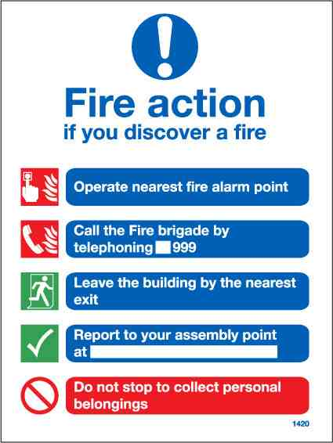

Fire Alarm "Manual" Call Point

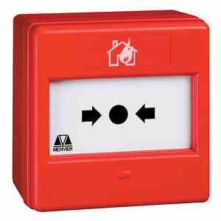

Assembly Point

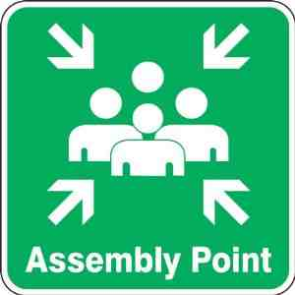

‘Fire Action’ notices are displayed throughout the building. These notices outline the action to be taken in the event of a fire.

Please familiarise yourself with these fire action notices.

Also familiarise yourself with the escape routes and fire exits from the building.

Fire alarm manual call points are situated at final exits.

Please familiarise yourself with their location.

The assembly point is displayed on all "Fire Action" notices.

Please familiarise yourself with this location.

